https://www.jdoodle.com/embed/v0/68u9
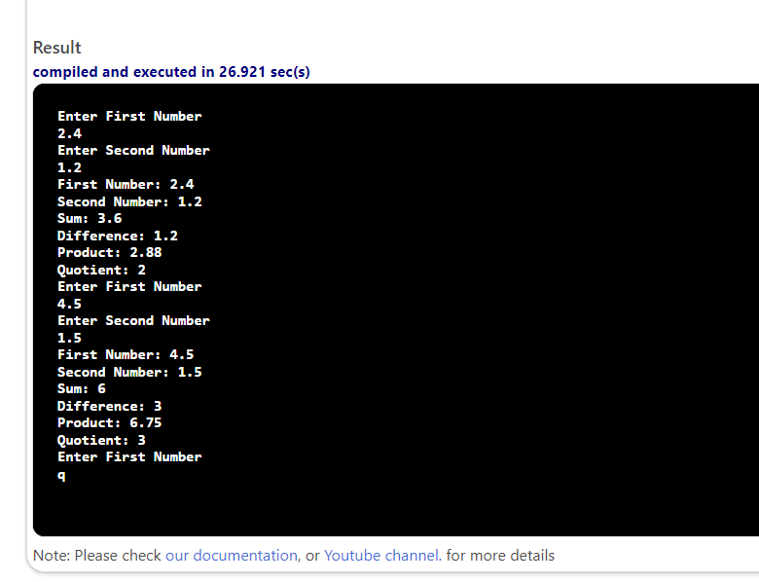

#include <iostream>
using namespace std;

void compute(double num1, double num2, double& sum, double& diff, double& prod, double& quotient)
{
sum = num1 + num2;
diff = num1 - num2;
prod = num1 * num2;
quotient = num1 / num2;
}
int main()

{
double n1, n2, s, d, p, q;
cout << "Enter First Number" << endl;
while (cin >> n1)
{
if (n1 == 'q')

{
break;
}

cout << "Enter Second Number" << endl;
cin >> n2;

compute(n1, n2, s, d, p, q);
cout << "First Number: " << n1 << endl;
cout << "Second Number: " << n2 << endl;
cout << "Sum: " << s << endl;
cout << "Difference: " << d << endl;
cout << "Product: " << p << endl;
cout << "Quotient: " << q << endl;
cout << "Enter First Number" << endl;
}

return 0;
}

